Structure of Systems - Viable System Example

Introduction
We said, in our introduction document, that we were interested, in the organisational structure, of systems, and the way, that such structures may evolve. In our notation document, we described the notations, that we use to describe such structures, and to describe their evolution. We use Venn diagrams, to represent organisational structures, and the Lambda functional notation, to characterise changes, to these structures.
This document provides one of the examples listed, in the documents section, of our introduction document. It gives a description, of the mechanisms, of the Viable-System Model (VSM), as presented in the book, ‘Diagnosing the System for Organisations’, by Stafford Beer (see diagram at end of this document). We reference relevant pages, of this book, in this document. This book only covers a small part of the VSM story. More important aspects (organisations, models, motivation, history, and examples) are covered in Stafford Beer’s other books.
Stafford Beer’s book is primarily aimed at the managers, of organisations. It is concerned with organisational structure (declared above, as our main interest) - identifying the components, of the organisation, and the adaptive connectivity, between these components, [pages i and x]. It is not directly concerned with other aspects of management, such as finance, marketing, personnel, etc, [page x]. Although VSM was originally intended to model organisations, many of its ideas have been applied, to other systems, such as biological systems, social systems, [page 1], and IT systems.

Viable-Systems
Stafford Beer says a viable-system is capable of independent existence, within a specified environment, [pages 1 and 8]. In this definition, the word “within” is significant. Stafford Beer’s diagrams show the environments, to be separate from the viable-system, making the word, “with”, more appropriate, than “within”. However, Stafford Beer also says, that the viable-system produces and maintains itself, [pages 4 and 8], making “within” sensible. Thus, the choice between “within” and “with” depends on whether, or not, we choose, to include the viable-system, in its environment. The existence of predators and prey, parents and offspring, further complicates this choice.
This above definition means, that the viable-system keeps, within a limited range of states, that it, itself, defines and controls. It uses feedback loops, [page 99], to monitor and maintain this dynamic-stability, or homeostasis, [page 9].
Stafford Beer’s aim, in his book, is to identify the invariants, of viable-systems - the properties that are common, to all of them, [pages 13-15].

Our Representation of the VSM Model
Stafford Beer sees lines, in his diagrams, as representing the interactions, between the systems, represented by boxes. As we said, in our notation document, we prefer to consider systems and interactions, as dual concepts – with interactions needing support, by systems, and systems existing, to support interactions. We will treat each of Stafford Beer’s lines and boxes, as representing one type of object, a system, and we will use a notation, that emphasises this.
The starting point, for our representation, of the VSM model, is the following diagram:
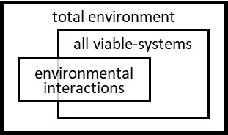
Stafford Beer recognised, that a viable-system must have a set of components, which are also viable-systems. He also recognised that the viable-system must be a component of many container viable-systems. For instance, a person may belong to a family, a community, a nationality, a company, a profession, a university, a school, etc., [pages 5-6], and all of these affect its operation.
Stafford Beer recommended, that, at any point in time, we should concentrate our attention, on one viable-system, a System-in-Focus, and consider its relationships with its environment and with its component and container systems, [page 6]. The following diagrams show this recursive structure, [page 2], with System in Focus in level-i, container systems in level-i+1, and component systems in level-i-1:
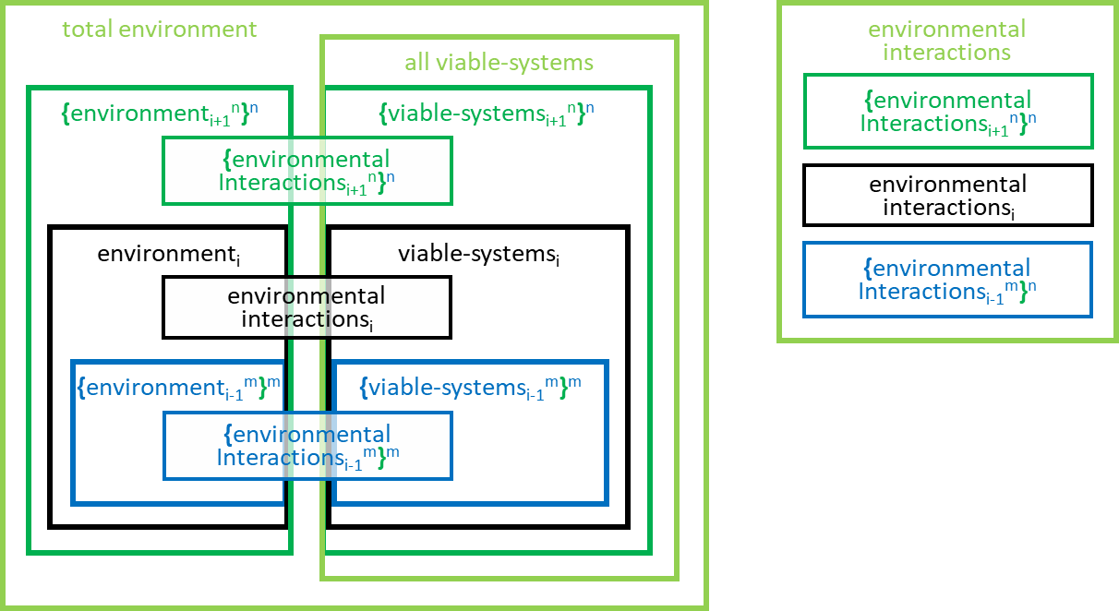
We use colours in these diagrams (as well as subscripts, _{i-1}, _{i}, _{i-1}) to emphasise the levels of recursion. Note, also, the use of { ^{n}}^{n} brackets and superscripts, for members of a set - that is explained below. These are very important additions, to our notation, and we will need them again, in later diagrams.
The diagrams, that we develop, in this document, are all Venn-diagrams. We noted, in our notation document, that Venn-diagrams are geometrically capable of representing, only, a limited number, of interactions. If we had tried to represent all container and component systems, in the diagram, it would have taken us, well beyond this geometrical limit. Hence, in this diagram, we have just shown the sets of these containers and components. We have used brackets, { ^{n}}^{n}, to indicate sets, of whatever is inside the brackets. The members of the sets can be distinguished, from each other, by the values of the superscripts, e.g., ^{n} and ^{m}, for containers and components. Later diagrams will consider the members, of the sets.
Note, that the above diagrams show each viable-system interacting, with the total environment, as well as its own environment. Stafford Beer said that this was necessary, as each viable-system needs to look, in unanticipated ways, beyond its own environment, when predicting its future, [page 113]
Stafford Beer made a strong distinction, between the set of viable-system components, of a viable-system, and its other, non-viable-system, components. He reinforced this distinction by introducing two systems, Operations and Management, to separately contain the two sets of components, [page 21]. He said that Operations gave the viable-system the ability to self-produce (self-create, self-evolve, and self-repair) itself (including its components, its boundaries, and products it produces), while Management_{i} maintained the homeostasis, of the viable-system_{i} (ensuring the dynamic-stability of its production within an unpredictably changing environment), [pages 7-9, 19-21].
He took the decomposition process further, seeing each Management component, as composed of a Senior-Management component, and a set of System1 components, [page 19], managed and coordinated, by the Senior-Management, [page 39].
The concepts, of the last few paragraphs, result in a System-in-Focus, like the following:
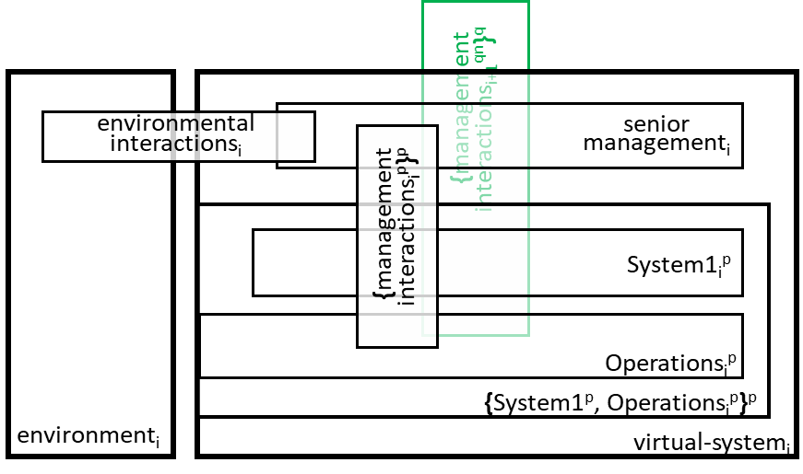
Management Interactions_{i+1} allow coordination, by container viable-system_{i+1}s, and Management Interactions_{i} allows coordination, of component viable-system_{i-1}s. Note, that, in each level of recursion, there is just one Senior Management_{i}, and a set of System1_{i}^{p}/Operations_{i}^{p} pairs (with superscript ^{p}). The next diagram shows the System-in-Focus system, at recursion-level i, with its container viable-systems, at level i+1, and component viable-systems, at level i-1:
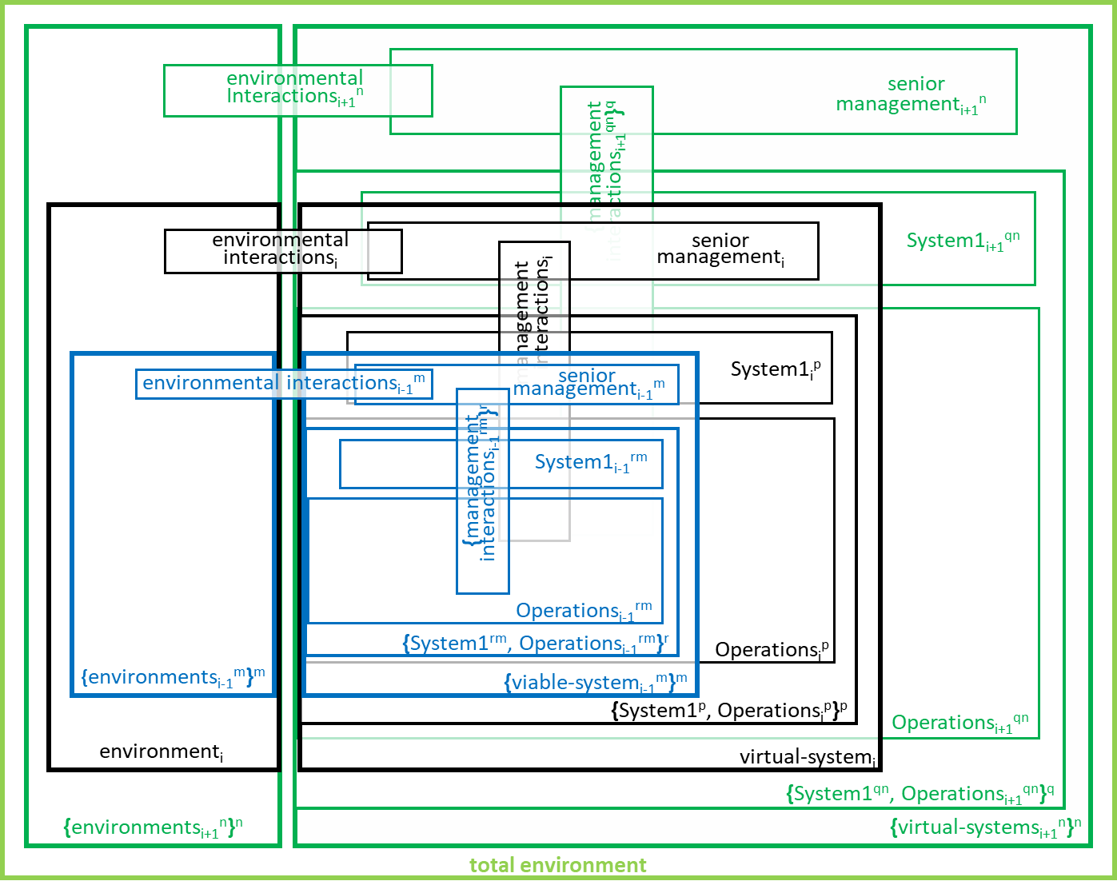
We have now used the subscripts, i, i+1, and i-1, for levels of recursion; superscripts, n and m, for sets of container and component systems, and p, q, and r for sets of System1/Operations pairs.
Note, that the names, of some systems, have required two superscripts. This is because those systems are nested, as members, within two sets. The superscript, outside the brackets, is the one that varies, for the members, of the set, within the brackets.
In later diagrams, the nesting, of sets, might extend, beyond two sets. It does not need to, in the above diagram, because there is only one system, at level i. Here, all container systems affect the System-in-Focus, and all component systems are affected by it. The effects are not nested.
Stafford Beer’s definition, of this recursive structure, [pages 19, 20, and 136], had geometric implications, for the above diagram. Firstly, it implied that System1_{i}, at one level of recursion, must encompass Senior-Management_{i-1}, in the next lower-level, [page 19]. Secondly, it implied that Operations_{i}, at one level of recursion, must encompass the set of System1_{i-1}/Operations_{i-1} pairs, in the next lower level. Implied by these two constraints is a third constraint - that each viable-system_{i-1} resides within Operations_{i+1}s, in the viable-system_{i+1}s, two recursion levels higher.
These constraints apply, because both System1_{i}, and Senior-Management_{i-1} are responsible, for coordinating the same set, of System_{i-1}/Operations_{i-1}s pairs. System1_{i} does this on behalf of viable-system_{i}, at level i. Senior-Management_{i-1} does it on behalf of viable-system_{i-1}, at level i-1.
All interactions, between the different levels of recursion, are encompassed within these relationships between System1_{i}s, at one level, and Senior-Management_{i-1}s, at the next lower-level. We explore these relationships later.
We can now concentrate on the System-in-Focus, at level-i, and its interactions, with its containers and components, in neighbouring levels, i+1 and i-1, as shown above. Stafford Beer split Senior Management into three component systems, with the names System3 [page 85], System4 [page 111], and System5 [page 129], so we will modify our earlier diagram to show this split:
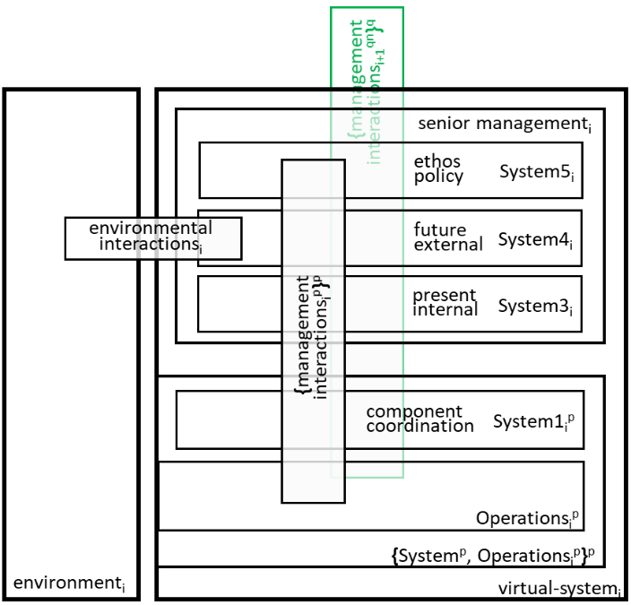
We have already said, above, that the System1_{i}s, in the viable-system_{i}, in recursion-level i, contribute to the coordination and management of the viable-system_{i-1}s, in level i-1, with the aim of ensuring, that they contribute to the interests, of the viable-system_{i}, that contains the System1_{i}s.
System3_{i} focuses on the ‘here and now’, of its viable-system_{i}. It ensures that the set of System1_{i}s, jointly achieve the current interests, of viable-system_{i}.
Just, as System3_{i} concentrates, on the ‘here and now’, of its viable-system_{i}, so System4_{i} focuses, on the ‘there and then’, of viable-system_{i}. It considers product design, market potential, technological development, production technique, etc., in order to develop a future strategy, [pages 113-5].
System4_{i} maintains a model of System3_{i} and System4_{i} and their strategies and interactions, and strives for homeostasis, or dynamic-stability, of the relationship between them. System4_{i}s model [page 115] gives a realisation, of Stafford Beer’s concept of self-awareness, [page 4]. In many organisations, there will be a physical home, for this model - a management suite, or operations room – thus providing Stafford Beer’s organ of adaptation, for viable-system_{i}, [page 120]
The System1_{i+1}s, in level i+1, interact with System5_{i}, in level i, to ensure that viable-system_{i} contributes to the interests, of the container viable-systems _{i+1}s. To do this, System5_{i} must, as far as possible, incorporate these interests, into the purposes and ethos, of viable-system_{i}. Formulating the purposes requires a delegate balance (involving Stafford Beer’s comparators and feedback, [page 98]), between the demands, coming from the System1 _{i+1}s, and the strategies deemed possible, by System4_{i} and System3_{i}. The ethos, or atmosphere, of viable-system_{i}, provides an almost invisible boundary, constraining the possibilities and ambitions of System4_{i}, [page 124].
System5_{i} is the ultimate authority, the boss, [page 125], for the viable-system_{i}, and, particularly, the ultimate authority, for the homeostasis, or dynamic-stability, of the relationship between System4_{i} and System3_{i}. It normally takes no action, but occasionally favours the ‘there and then’, of System4_{i}, and sometimes the ‘here and now’, of System3_{i}. By its involvement, it determines the level, of authoritarianism, that pertains within the viable-system_{i}, [page 101].
Stafford Beer split the management-interactions in three, as shown in the following diagram:
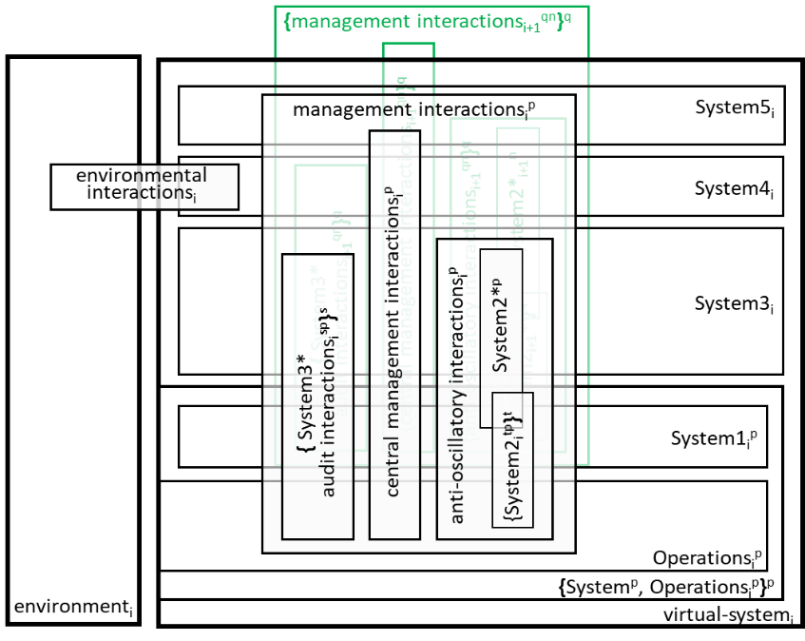
Stafford Beer recognised, that multiple system 3_{i}*s are required, as there are multiple reasons for audits, e.g., management, buildings, machines, hygiene, etc. [pages 82 and 93]. Hence the superscript s, in the above diagram.
System3_{i} has the main responsibility, for all audits, but System3_{i}*s support this, by doing the detailed work. System3_{i}*s may use information, that is not possessed by System3 _{i}, but they do not have authorities, independent of System3_{i}.
The anti-oscillatory systems, shown in the above diagram, assist System 3_{i}, with detailed coordination of the set, of System1_{i}/Operations_{i} pairs, [page 67 and 83-87]. They are, in particular, responsible, for the dampening of oscillations. Oscillations occur, when each System1_{i}, tries, to get the others, to adjust their activities, for its benefit, and no system is looking after the shared needs, of all System1_{i}s. The oscillations may be reflected, in the environment, so aggravating the problem.
There are a set, of anti-oscillatory boxes, in the diagram, because there are multiple reasons, for their presence - for production, safety, personnel, house-style, ethics, timetabling, litigation-threat, etc, [page 75]. Hence the superscript t, in the above diagram.
Each anti-oscillatory system is shown, by Stafford Beer, to be implemented, with two subsystems, both represented, by a triangular box, and both named System2_{i}. We have given one of them the name System2*_{i}. There is one System2*_{i} system, for each reason for coordination, and each of these has a set of System2_{i}s, linked to the set of System1_{i}/Operations_{i} pairs.
Systems_{i}3, 3*, 2*, 2, and 1, between them, provide homeostasis for the ‘here and now’, while Systems_{i}5, 4, 3, between them, provide homeostasis for the ‘there and then’. System3 is the fulcrum, between these homeostasis, and hence is sometimes mistaken, for the boss, [page 129].
As we noted above, Stafford Beer said, that only System4_{i} interacts, with the environment. He later said that there were two types of interaction, those concerned with the known future and those trying to predict the unknown future, [page 119]. Stafford Beer referred to the unknown-future-interactions as α-interactions and the known-future-interactions as β-interactions.
This gives us an implementation, for the environmental-interaction_{i}s box, in the previous diagram:
,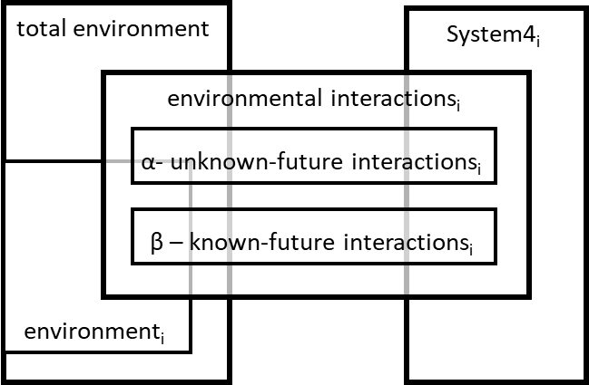
That leaves just one box, in the diagram before last, that we have not discussed – the central management interactions. The following gives an implementation, for that box, [pages 39, 57, 93,]:
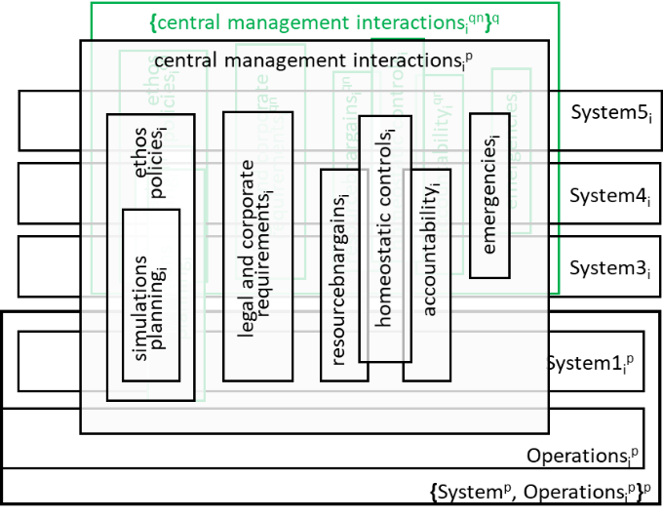
The green boxes in the diagram show, where the System-in-Focus (in black) is affected, by interactions, with one of its container viable-system_{i+1}s, which are in the next higher recursion level (in green). Captured within System1_{i} and Operations_{i}, there is a lower-level (i-1) version of the boxes, which the black version interacts with, just as the green version interacts with the black. This diagram shows us where the interactions, between recursion-levels, take place. As we said earlier this is between the System1_{i+1}s and the Senior-Management_{i}s (which includes System5_{i}s, System4_{i}s, System3_{i}s, and System2*_{i}s
The resource-bargain and accountability boxes form a dialogue, with the System3_{i} making resource bargains, downwards, and with the System1_{i}s, and the System1_{i}s accounting, upwards, for their use, of the resources. Because of its responsibilities, System3_{i} emphasises the resource needs, of the ‘here and now’, in this bargaining. It is up to System4_{i}, to represent the ‘there and then’. Hence, the balancing act, or homeostasis, between System4_{i} and System3_{i}, and System5_{i}’s role in moderating it, as described above. All, of these dialogues, are influenced, by the equivalent dialogues, in the container viable-system_{i+1}, (in green).
Ethos, policy, and legal and corporate requirements come down from System5_{i}, and simulations and plans come down from System4_{i} and System3_{i}. All of these may be influenced, by the equivalents, in the container viable-system_{i+1}.
System5_{i} has the power, to declare emergency situations, in extreme situations (Stafford Beer’s algedonic), [page 133].
We now need to introduce the term, Variety. This is probably the most important concept, in Stafford Beer’s book – the work on VSM has been called Variety Engineering, and this has been presented, as a way of Managing and Constraining Complexity. The term, variety, was first coined, by Ross Ashby, when he was working on control systems. Ashby used the term, for the number of possible states of a system. In the context of control systems, he formulated a Law of Requisite Variety, that said that the variety, of the controlling system, must be greater than the variety, of the controlled system. Of course, it may not be possible to calculate a number, for the size of the variety set. However, it is usually possible, to compare these sets and their sizes, for different systems, [pages 21-27]. For instance, referring to Stafford Beer’s earlier diagram, we can see that the variety, of the Management, must be less than the variety, of the Operations, and the variety, of the Operations, must be less than the variety, of the Environment. [page 22].
Stafford Beer started to deal with interactions (his lines and our interaction boxes), in pages 22-34. His examples on pages 22-27, concentrate on interactions, that transfer information between Management, Operations and Environment. Furthermore, they concentrate on interactions, whose sender, of information, has much larger variety than its receiver – specifically, interactions where the flow of information is from Environment to Operations, or Operations to Management. It becomes clear, from these examples, that Stafford Beer was shifting the definition, of variety, from Ross Ashby’s original definition. His examples are concerned, with the variety, of the information, transferred by the interactions. They are not concerned, with the full variety, of the sending system, or of the receiving system, or of the interaction system, itself. His version, of Ashby’s law, said that the variety transferred cannot be, beyond the variety, of the receiving system. It is obviously not. beyond the variety, of the sending system.
Thus, the information transmitted, by the interaction, cannot have variety, beyond the capabilities, of either sender, or receiver. Stafford Beer recognised, that the variety, of information, that the sender wants to transfer, will need to be restricted (attenuated) to be within the variety, of information, that the receiver can receive. [page 23].
Stafford Beer also recognised, that the situation, described in the previous paragraph, will evolve. The sending system will, from time to time, find that extra variety is required, or discover some is not required. The sending system will need to be able to notify the receiving system, of its new requirements. The receiving system will need to consider how it can satisfy the requirements, within its capabilities and any achievable extensions, thereof. It will then need to reply, to the sending system, with an amplification interaction, [page 27].
The attenuation and amplification interactions allow a dialogue, between the two systems, involved in the interaction. They can use this dialogue, to maintain the dynamic-stability (homeostasis), of their interactions.
The interacting systems may need to be physically, or logically (i.e., organisationally), remote from each other. Stafford Beer introduced the concept, of a channel, to support transfers via the interaction. Channels could be letters or documents, to carry information. At one point, Stafford Beer seemed to say, that the Post Office was a channel, [page 45]. This has the danger, of making viable-systems internally dependent, on a huge shared and independent viable-system, the Post Office. Channel capacity, or throughput, is important to the interaction – it adds a time dimension, to the definition, of the interaction. The throughput, of the channel, must be greater than the output rate, of the sender end of the interaction.
Stafford Beer also recognised that transfers, via an interaction, may need to be converted, to suit the tastes, of the receiving system. For instance, information may be translated, between languages, or artefacts may be modified, e.g., painted, or augmented. He refers to these changes, as transduction. The throughput, of the transducer, must at least match the throughput, of the channel.
Redundancy in information transfers is important. This enables errors in transmission to be corrected.
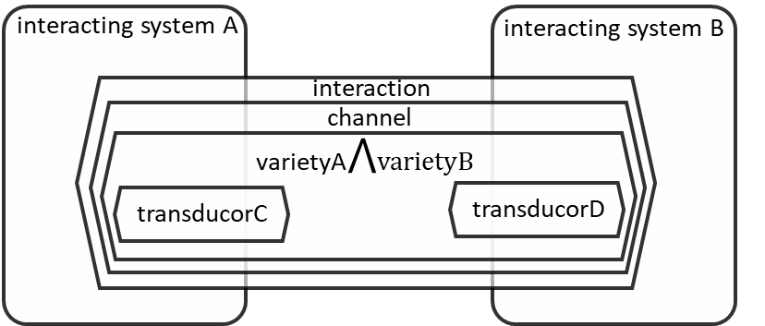
Although, this story, about the attenuation and amplification of variety, and about channels and transducers, has concentrated on the interactions that transfer information, the ideas could be applied, to more complex interactions, for instance, interactions that transfer artefacts, or even more complex systems.
Stafford Beer introduces the idea of horizontal and vertical axis for his diagrams [pages 50, 82 ,84]; the horizontal axis including interactions, within a level of recursion, between cooperating viable-systems and between them and the environment; the vertical axis containing interactions between levels of management and levels of recursion. Stafford Beer said that the sum of horizontal variety equals the sum of vertical variety [page 84].
Stafford Beer pointed out, that ethos acts, as an almost invisible variety sponge, inhibiting people from suggesting products, markets, or methods, beyond the norm, of an organisation. He also identified the audits, by System3*, as a means, of replenishing System3’s variety, and noted, that although, System2_{i}*, System2_{i} and System3_{i}*, are adjuncts of System3, totally under its control, they may have variety (e.g., detailed databases), beyond that of System3.

Historic Background
We mentioned Ross Ashby above. He and Stafford Beer were leading figures in the cybernetic community. Some of the creators of cybernetics drew on the work, on entropy and the theory of life, by Boltzmann, Schrodinger, and others. We reviewed this connection to entropy in our introduction document.

Page 136 Model
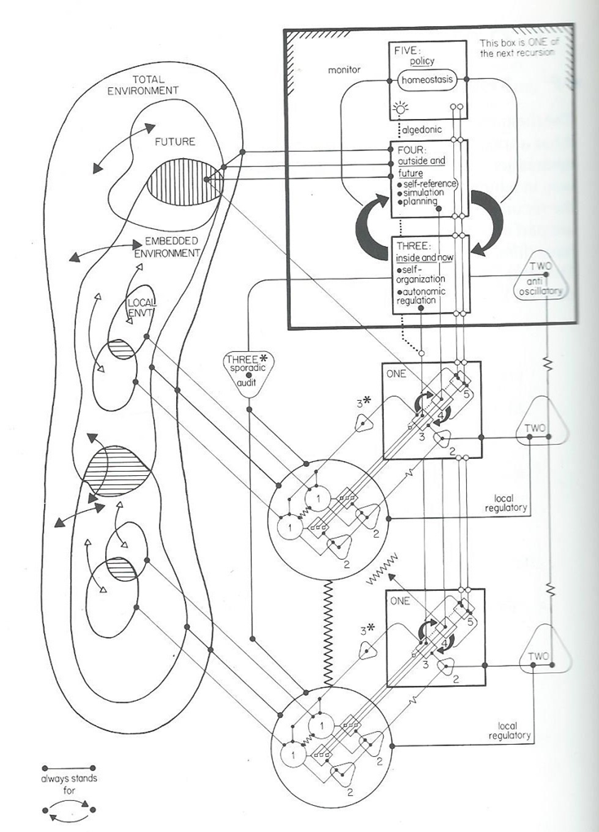

Sketch of Our Diagrams

